A000-Eur-Roman-Rhyton-Horse-Bronze-100 CE

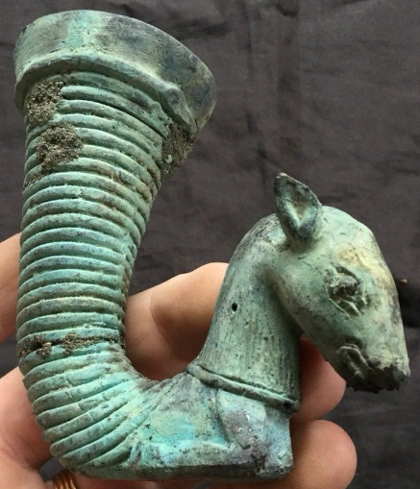

Roman-Rhyton-Horse-Bronze-100 CE

**Case no.: 4**

**Accession Number:**

**Formal Label:** Roman-Rhyton-Horse-Bronze-100 CE

**Display Description:** Bronze Roman Rhyton with a horse’s head. From a private British collection.

**LC Classification:**

**Date or Time Horizon:**

**Geographical Area:**

**Map:**

**GPS coordinates:**

**Cultural Affiliation:**

**Media:**

**Dimensions:** H 10 cm x W 10 cm, Dia 4.5 cms

**Weight:** 194 **gm**

**Condition: original**

**Provenance:** From a private British collection.

The Roman legion evolved from cohorts in the early Roman army but the development of subsequent legion organizations and emblems varied greatly over time. Typically, legions were comprised of around five thousand soldiers, and during the Republican Era, a legion was divided into three lines of ten maniples. In the Late Republic and much of the Imperial Period, a legion was divided into ten cohorts, each of six centuries. Legions also included a small *ala* or cavalry unit. By the third century CE, the Roman legion was a much leaner and better trained unit of about 1,000 men.

References:

Koehl, R.B., 2006. *Aegean Bronze Age Rhyta*. Institute for Aegean Prehistory Press.

Parker, Henry Michael Denne. 1993. *The Roman Legions*. New York, N.Y.: Barnes & Noble.